User Guide

* **DirectFN™ DFIXRouter License Generator**

**Document Revisions**

|  |  |  |  |
| --- | --- | --- | --- |
| ****Date**** | ****Version**** | ****Description**** | ****Author**** |
| ****2020-06-25**** | **1.0** | **Initial draft** | **Muhammadh Aadhil** |
| ****2020-08-19**** | **1.1** | **Forever/Unlimited Duration added** | **Muhammadh Aadhil** |
|  |  |  |  |

Contents

1 Introduction 4

1.1 Purpose 4

1.2 Pre-Requisites 4

1.3 Steps to generate License 5

1.3.1 Start Application. 5

1.3.2 Maximum allowed Parallel Instances 6

1.3.3 Maximum Allowed Sessions 7

1.3.4 License Start Date 8

1.3.5 Insert New Row for License data 9

1.3.6 Conclude the Input Mode 12

1.3.7 Generate 12

# Introduction

## Purpose

This document provides the instructions to use the DFIXRouter License Generator application. It is used for License Generation for DFIX Router.

## Pre-Requisites

1. Works only with Windows based machine.
2. Java – 1.8.
3. Need to provide **Non-Obfuscated** DFIXRouter-x.x.x.x.jar as a library.

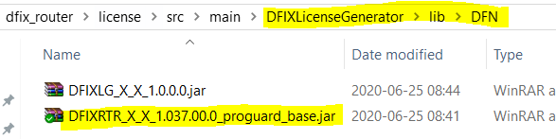

## Steps to generate License

### Start Application.

* Run below highlighted batch file to start the application.

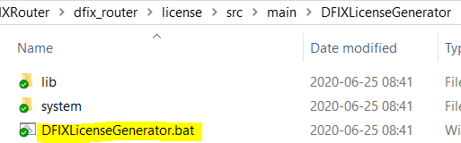

* Application will provide below GUI

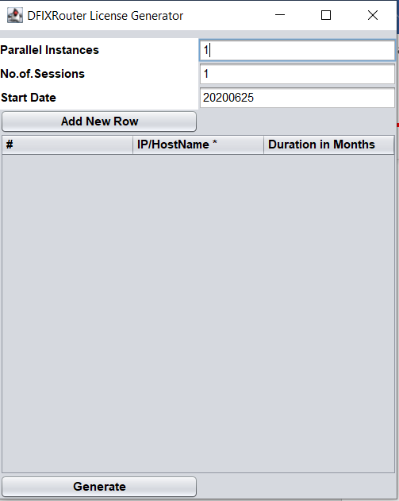

### Maximum allowed Parallel Instances

* This parameter is used to provide High Available Solution For DFIXRouter.
* Minimum allowed value is 1.
* Maximum allowed value is 127.

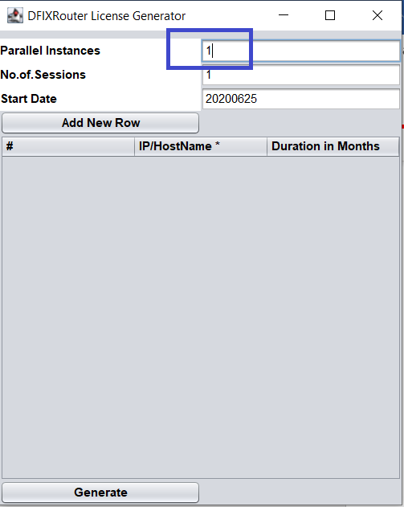

### Maximum Allowed Sessions

* This parameter is used to set the allowed number of sessions for DFIXRouter.
* Minimum allowed value is 1.
* Maximum allowed value is 127.

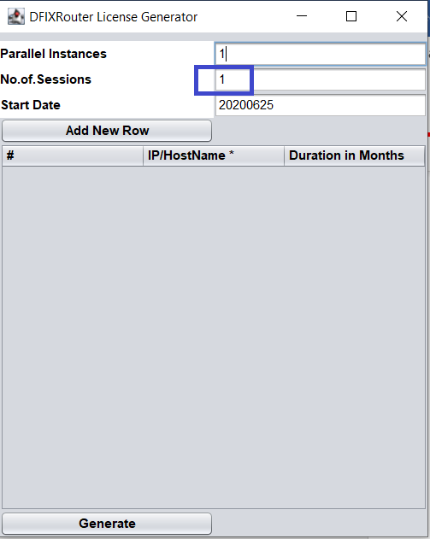

### License Start Date

* This parameter is used to set the start for the License.
* Date should follow the format *‘YYYYMMDD’*
* If the License is based on Duration, this parameter is compulsory.

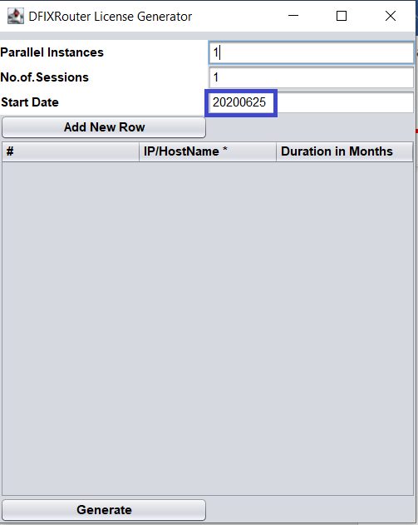

### Insert New Row for License data

* Press the button *‘Add New Row’* to insert the data.
* It will provide a space to enter the IP/Host name and Allowed Sessions count to input.

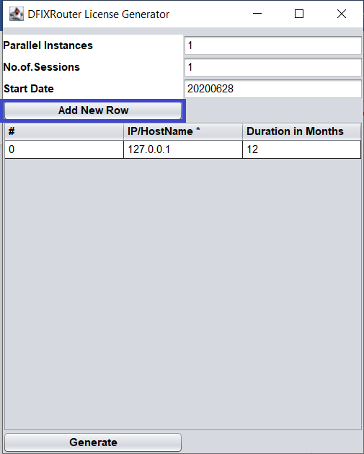

#### IP/Host Name

* This parameter is used to provide the Targeted Server IP or Host Name.
* Provided IP cannot be a Loop backed IP.
* Maximum we can add 40 Rows of data.

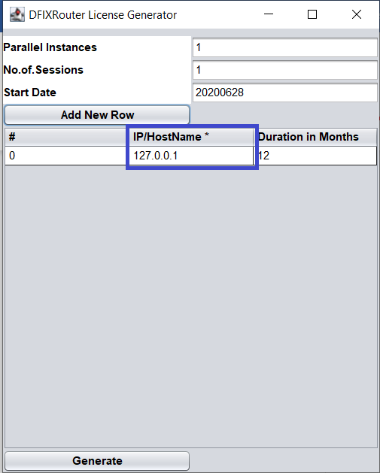

#### Duration

* This parameter is used to provide the valid period for the License to the corresponding Server which is discussed in ‘IP/Host Name’
* This has to be given as a number which is indicates the Number of Months from ‘Start Date’ discussed earlier.
* Minimum allowed value is 1.
* To give Forever/Unlimited License, use wildcard ‘**\***’.
  + Don’t forget to press ‘Enter’ to finish the input.

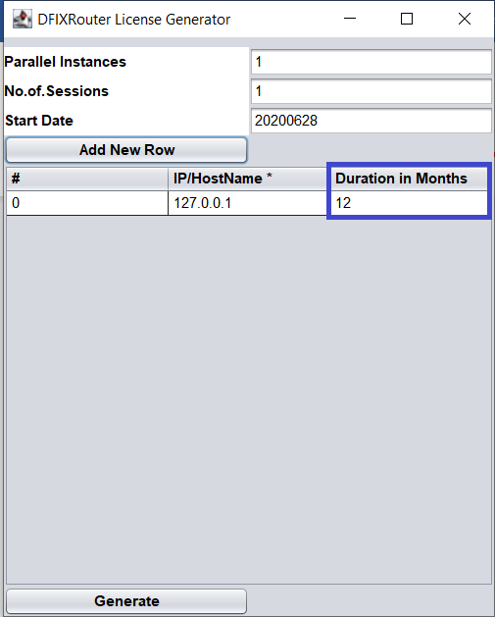

### Conclude the Input Mode

* Don’t forget to press ‘Enter’ to finish the inputs.
* Once all the parameters accepted by the UI, all of them will be filled with Blue colored Tile as below.

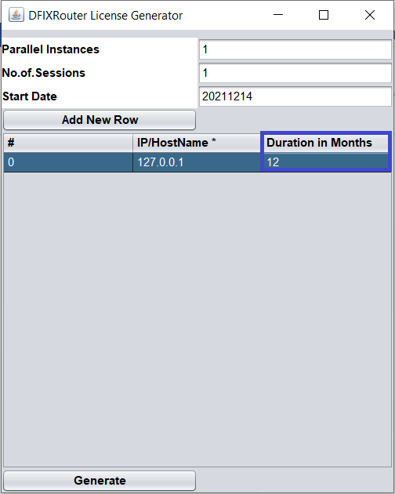

### Generate

* After fill, the data as discussed earlier, Press the button *‘Generate’*.
* This will generate a File with name **‘LicenseDetails.license’** in the **‘System’** folder.

